3º ESO

BUDISMO

VIDA Y DOCTRINA DE BUDA. Buda (viene del sánscrito Buddha, que significa «el iluminado») nació en Nepal, hacia el año 557 a.C., en una familia de aristócratas. Su madre murió pocos días después del parto y por esto fue criado por su tía. Vivió rodeado de lujo y se casó, teniendo un hijo. Empezó a observar en otras personas la vejez, la enfermedad, la pobreza y la muerte, que se repetían en el ciclo de las reencarnaciones y, desde entonces, intentó hallar un remedio a estos males. Como el lujo en el que vivía no podía responder a sus preguntas, se marchó dejando atrás su casa, su familia, esposa e hijo, para convertirse en un asceta vagabundo: según la tradición budista, hizo ayuno al modo de los brahmanes hindúes hasta quedarse casi esquelético, pero no halló en la ascesis la respuesta. Siguió meditando siete años y llegó un momento en la vida de Buda («iluminación») en que halló que el ciclo de las reencarnaciones, pernicioso para el ser humano, puede romperse conociendo las causas del dolor y la vía para eliminar ese dolor.
Buda enumeró las nueve formas que tiene el diablo de tentar y que llevan al pecado: la voluptuosidad, el descontento, hambre y sed, deseos, pereza e inacción, cobardía, duda, hipocresía, afán de gloria, y orgullo.
Y en su sermón de Benarés las «cuatro nobles verdades sobre el dolor.»:
1. Todo es sufrimiento.
2. Está producido por el deseo y la ignorancia.
3. El dolor se elimina evitando el deseo. (El nirvana no es un paraíso al modo de otras religiones, sino el estado individual en el que, habiéndose eliminado totalmente el sufrimiento, se pierde la identidad personal, la cual se funde con el principio absoluto que es dios y participa de él. Puede obtenerse tanto en esta vida como después de la muerte.)
4. La forma de eliminarlo es seguir los ocho senderos.
Así, Buda expuso «el noble camino de los ocho senderos»:
conocimiento de las cuatro verdades
actitud recta (para evitar los deseos y la malicia)
palabra recta (uso de un lenguaje prudente y sincero)
acción recta
ocupación recta
esfuerzo recto (que fomenta los buenos pensamientos)
pensamiento recto (buscar la verdad sin apasionamiento)
concentración recta (para fomentar la meditación)
Buda predicó palabras como las siguientes:
«No hay falta que pueda ser redimida. El hombre nace solo, vive solo y muere solo. Él recorre el camino que puede llevarle al nirvana, el mejor reino del no ser, del no ser ya.»
Predicó desde entonces sus ideas y murió a los ochenta años en un bosque, rodeado de sus discípulos. En el s. III a.C. el budismo fue impulsado por el rey Asoka y se extendió por la India y zonas cercanas, creándose multitud de monasterios budistas (al jefe de un monasterio budista se le llama «lama») Sin embargo, desde la Edad Media hasta el s. XIX d.C., el budismo casi desapareció de la India, teniendo más éxito en China, Tíbet, Japón, Corea, Birmania, Indochina, etc., lugares, algunos de ellos, donde se convirtió en religión de estado. Hoy vuelve a surgir con fuerza en la India.
Buda no negó la existencia de los dioses hindúes, pero los excluyó de su doctrina ya que consideraba que adorar a un dios no es camino para llegar al nirvana, la eliminación total del dolor. Por eso, no niega la bondad de otras religiones o éticas, pero se muestra indiferente frente a ellas. Sin embargo, al mismo tiempo, se basa en anteriores creencias, como la reencarnación, doctrina que aprendió del hinduismo.

DIVISIONES. En el budismo hay muchas divisiones, pero básicamente hay dos tradiciones que son las importantes, con textos y lenguas diferentes: la septentrional (norte) y la meridional (sur), llamadas respectivamente budismo Mahayana y budismo Hinayana. El primero busca la salvación de todos los hombres. El budista ideal de este camino es el bodhisatva, persona que intenta liberar a los demás antes de liberarse a sí mismo, aunque para ello tenga que reencarnarse muchas veces. El segundo se centra en la salvación de unos pocos: los monjes. Hay otra tradición posible y compatible con las otras dos: el budismo Vajrayana o Budismo Tántrico, el cual difiere del Mahayana en el método: hace sentir a la persona las emociones más intensas para llevarle a las cualidades que le acercan al nirvana.
La doctrina budista original es muy simple, pero las posteriores ramas budistas fueron complicándola hasta extremos irrisorios. La existencia de templos se debe a algunas ramas budistas donde se considera a Buda como dios y se le adora. En otros lugares, las diferentes representaciones de Buda se han convertido en casi objetos de culto, ya que cada una de ellas representan bienes como el amor, sabiduría, riqueza, alegría, buena suerte, etc. Pero, en general, no hay templos ni sacerdotes, ya que las oraciones no sirven, los pecados no se pueden perdonar, y adorar a un dios no surte ningún efecto.

EL TÍBET. El budismo llegó al Tíbet en el s. VII d.C. y tuvo un gran éxito. Se fusionó con la religión local, llamada «Bon», y el resultado fue el actual lamaísmo. Al jefe de este budismo actual del Tíbet se le llama «Dalai Lama». Es también el jefe temporal de este país desde el siglo XVII, aunque hoy desde el exilio, ya que actualmente (año 2005) el Tíbet está bajo dominio de China. En el lamaísmo se representan las llamadas «deidades»: no son dioses sino personificaciones de las cualidades que el seguidor de la tercera vía (budismo tántrico) ha de conseguir. Los seguidores del lamaísmo practican, sobre todo, el Mahayana, pero también muchas personas siguen el Vajrayana. De hecho, cierto tipo de budismo tántrico es identificado con el lamaísmo.
CHINA. Su budismo se llama Zen o Chan. Lo más utilizado en sus meditaciones son la reflexión sobre acertijos sin solución.

IMÁGENES DEL BUDISMO
Imágenes de Buda:
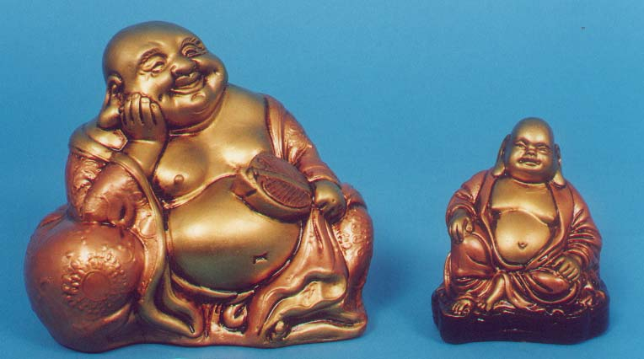
En esta representación aparece gordo. Esto quiere hacernos ver que el budismo no es necesariamente un camino de ascesis ni de santidad sino de eliminación del deseo mediante la meditación.
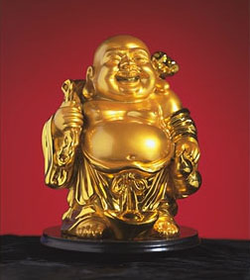
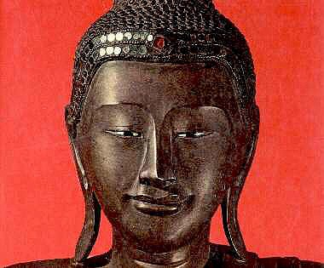
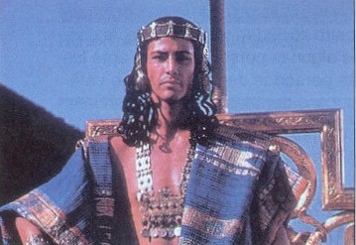
El príncipe Siddartha Gautama en la película El pequeño buda

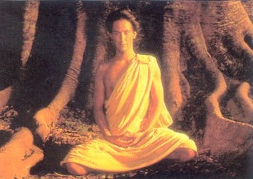
Siddartha Gautama cuando ya obtuvo la iluminación, Buda. En la peli El pequeño buda.

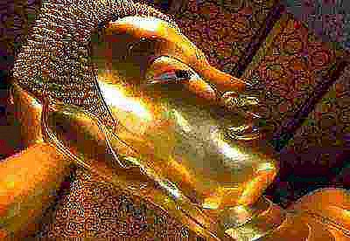
Buda acostado, cercano al nirvana.

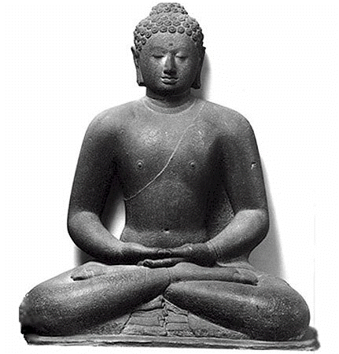

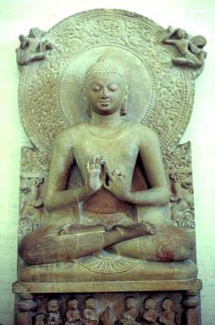

Repesentaciones de Buda en la posición de loto, en plena meditación.
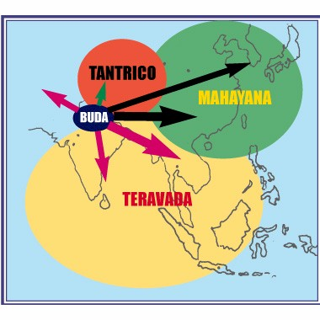
Distribución geográfica de las tres vías budistas.

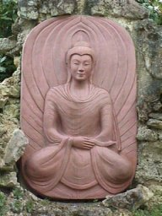
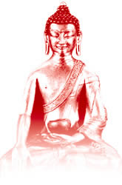
Budas en posición de loto.

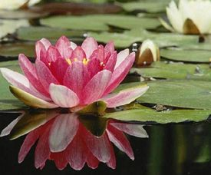
Flor de loto.

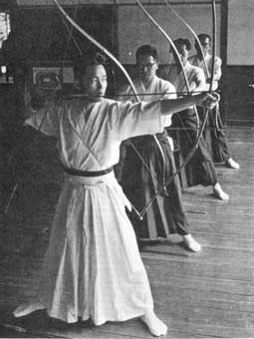
Arqueros japoneses en el budismo zen

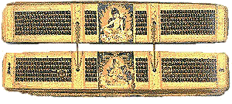
Canon Palí. Considerado tradicionalmente como el documento más fiel a las palabras de Buda.
• Imágenes de las «deidades» o cualidades deificadas que debe vivir el que profesa el lamaísmo,
• maestros budistas o
• representaciones de elementos budistas:

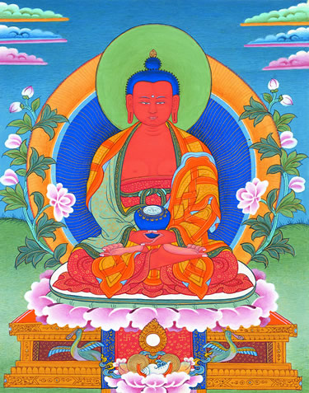

Amitabha
Amitabha is the Buddha of infinite light. His body of red light, the colour of the setting sun, symbolizes that he is the embodiment of the enlightened speech of all Buddhas.
His hands are in the mudra of meditative equipoise holding a bowl filled with nectars that symbolize his blissful realization of ultimate truth. His three robes symbolize his mastery of the three higher trainings (higher moral discipline,higher concentration, and higher wisdom).
He is the same nature as Buddha Amitayus.
Close

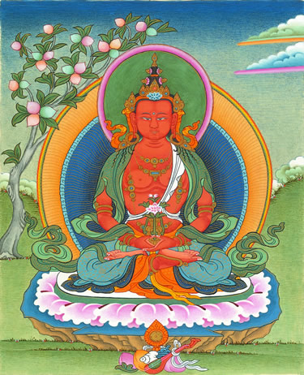

Amitayus
Amitayus is the Buddha of long life, merit, and wisdom. By engaging in Amitayus practice, we can develop these qualities — all essential for our spiritual development — and eventually attain the deathless state of enlightenment.
We can also use this practice to help remove obstacles that endanger the lives of others.
The practice can be found in The Yoga of Buddha Amitayus sadhana, the audio version of which is on the Songs of Long Life CD.

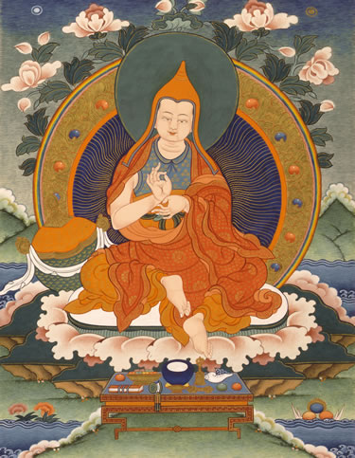

Asanga
Asanga was a great Indian Buddhist Yogi and scholar of the fifth century, author of Compendium of Abhidharma, who had a very close connection to Buddha Maitreya.
Due to his great compassion, he was famously able to purify all his karmic obstructions so that he could see Spiritual Guide, Buddha Maitreya, directly. See the book Joyful Path of Good Fortune for the full story.

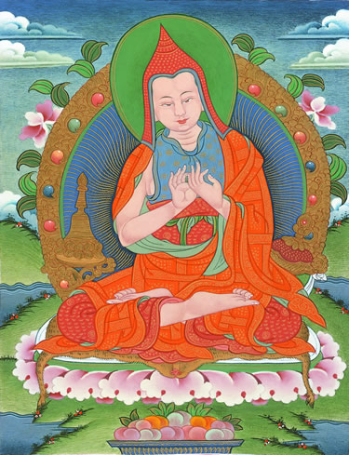

Atisha
Atisha (AD 982-1054) was a famous Indian Buddhist Teacher, and the author of Lamp for the Path, the first text on Lamrim (the stages of the path to enlightenment).
He was Abbot of the great Buddhist monastery of Vikramashila at a time when Mahayana Buddhism was flourishing in India.
He was later invited to Tibet and his arrival there led to the re-establishment of Buddhism in Tibet.
His tradition later became known as the “Kadampa Tradition”. See the book Joyful Path of Good Fortune for his life story.

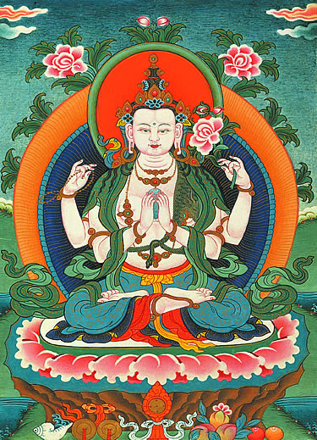

Avalokiteshvara
Buddha Avalokiteshvara, the Compassion Buddha, is the embodiment of the universal compassion of all enlightened beings. By relying upon him, we naturally increase our own compassion.
His first two hands hold a jewel, symbolizing his own enlightenment; his second left hand holds a white lotus flower, symbolizing his complete purity of body, speech, and mind; and his second right hand holds a crystal mala, symbolizing that he can free all living beings from samsara.
For more information, see Avalokiteshvara Sadhana (the audio version of which is available on the CD Songs of Wisdom and Compassion) or the book Living Meaningfully, Dying Joyfully.

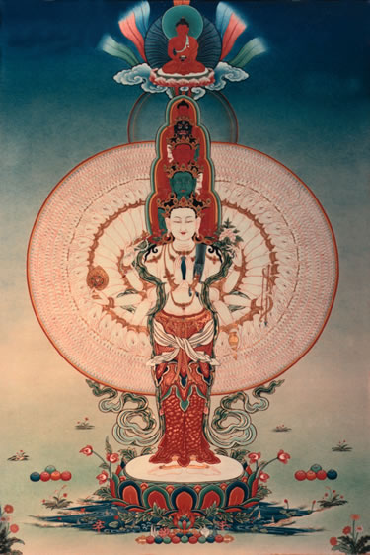

Thousand Arm Avalokiteshvara
Buddha Avalokiteshvara, the Compassion Buddha, is the embodiment of the universal compassion of all enlightened beings. By relying upon him, we naturally increase our own compassion.
He has a thousand arms, with an eye in the palm of each hand, demonstrating that he watches over and cares for infinite living beings
For more information, see the sadhana Drop of Essential Nectar

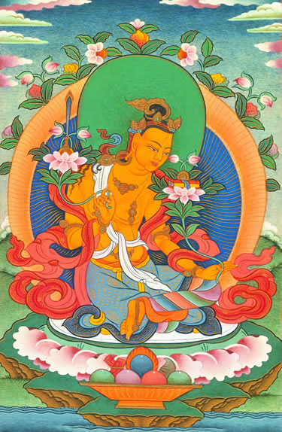

Bodhisattva Manjushri
Manjushri is the embodiment of the omniscient wisdom of all enlightened beings.
At the time of Buddha Shakyamuni, he manifested as a Bodhisattva disciple to demonstrate how one should practice as a Mahayana disciple.

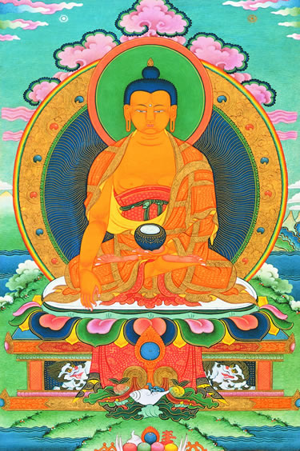

Buddha Shakyamuni
Buddha Shakyamuni is the founder of Buddhism in this world.
In general, “Buddha” means “Awakened One” — someone who has awakened from the sleep of ignorance and sees things as they really are.
A Buddha is a person who is completely free from all faults and mental obstructions. Every living being has the potential to become a Buddha.
See the book Introduction to Buddhism for Buddha Shakyamuni’s life story and the sadhana Prayers for Meditation and the CD Songs of Good Fortune for the Guru yoga of Buddha Shakyamuni.
Close
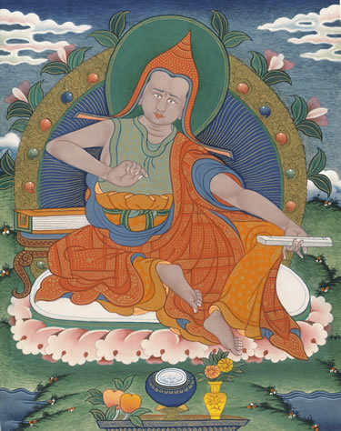

Chandrakirti
Chandrakirti (circa 7th century AD) was a great Indian Buddhist scholar and meditation master who composed, among many other books, the famous Guide to the Middle Way.
In this book, he gives an extraordinarily profound and clear commentary to emptiness, the actual nature of reality, according to Buddha's ultimate intention as explained in the Perfection of Wisdom Sutras.
See the book Ocean of Nectar for his life story and a full commentary to this text.

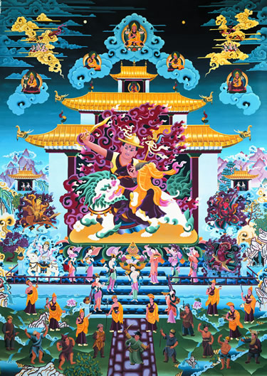
Dorje Shugdän
A Dharma Protector is a Buddha appearing in a protecting aspect, whose main functions are to avert inner and outer obstacles that prevent practitioners from gaining spiritual realizations, and to arrange all the necessary conditions for their spiritual development.
The Dharma Protector Dorje Shugdän is an emanation of the Wisdom Buddha Manjushri, who always helps, guides, and protects sincere practitioners by granting blessings, increasing their wisdom, and fulfilling their virtuous wishes. See the book Heart Jewel for more information.

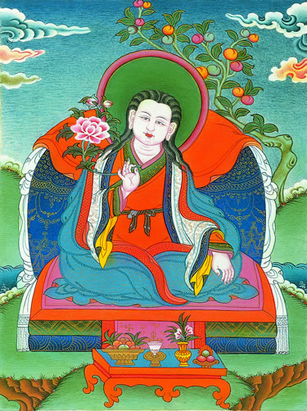

Dromtönpa
Dromtönpa (AD 1004-1064) was Atisha’s foremost disciple and is one of the lineage Gurus of our Kadampa tradition.
While in India, Atisha had received a prediction from Buddha Tara about this future lay disciple in Tibet, whom Tara said would cause Dharma to flourish far and wide.
After Atisha’s death, Dromtönpa was regarded as his representative and respected as his equal.

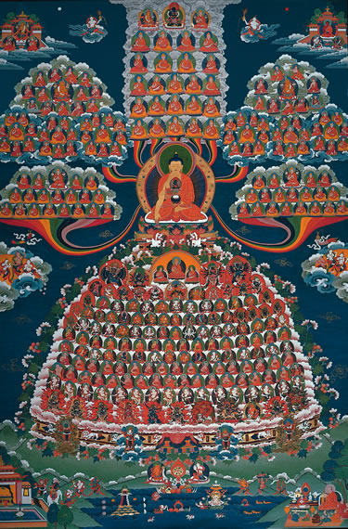

Field of Merit I
This depicts the Lamrim Field of Merit as described in the book Joyful Path of Good Fortune.
Buddha Shakyamuni is in the centre, surrounded by a vast assembly of holy beings, including Buddhas, Bodhisattvas, and all the lineage Spiritual Guides of Sutra and Tantra.
They are called a “Field of Merit” because by developing faith and making prayers and offerings to this assembly of holy beings, we create a vast amount of merit, or good karma, which prepares our mind for successful Lamrim (stages of the path) meditation.

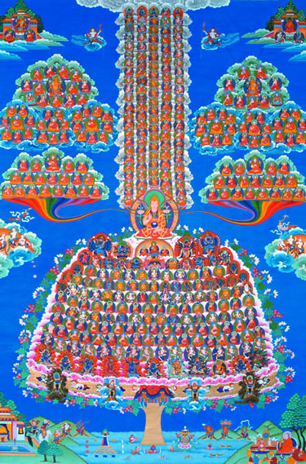

Field of Merit II
This picture depicts the main visualization for Offering to the Spiritual Guide, which is a special spiritual practice of Je Tsongkhapa’s tradition, done twice a month at all Kadampa Buddhist Centers.
The main practice is relying upon the Spiritual Guide, but it also includes the essence of all the stages of the path (Lamrim) and training the mind (Lojong), as well as all the Tantric practices.
The “Field of Merit” is so called because by developing faith and making prayers and offerings to this assembly of holy beings, we create a vast amount of merit, or good karma. See the book Mahamudra Tantra for a detailed description.
Close

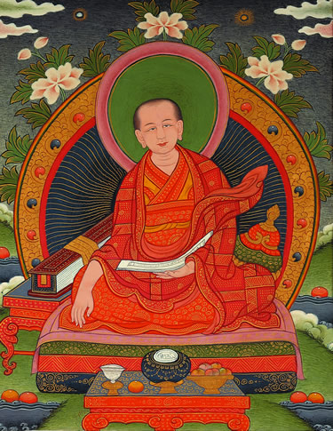

Geshe Chekawa
Geshe Chekhawa (1102-1176) was a great Kadampa Bodhisattva who composed the text Training the Mind in Seven Points, a commentary to which can be found in the book Universal Compassion.
He spread the study and practice of training the mind throughout Tibet.

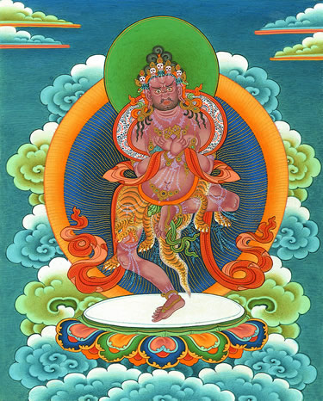

Ghantapa
Ghantapa was a great Indian Mahasiddha and a lineage Guru in the Highest Yoga Tantra practice of Vajrayogini.
For his inspiring life story, see the book Guide to Dakini Land.

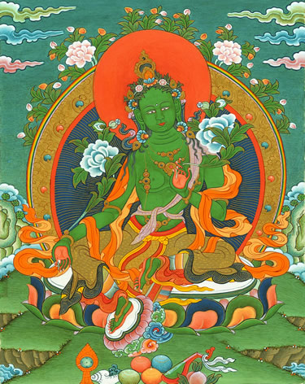

Green Tara
By offering praises and requests to Mother Tara, the female Buddha of wisdom and active compassion, we increase our fearlessness and swift wisdom and come under Tara’s loving care and protection.
Her green-coloured body symbolizes that she is the fully purified wind element and can respond swiftly to the prayers of those in need.
In lifetime after lifetime, Tara has manifested in female form to demonstrate that enlightenment is attainable by men and women alike.
See the sadhanas Liberation from Sorrow and Great Compassionate Mother, and the CD Songs of Liberation.

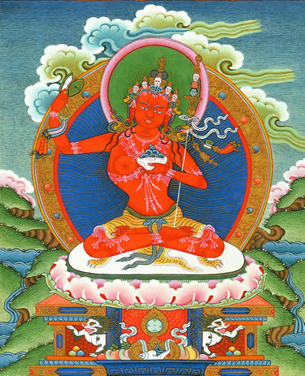

Lama Losang Tubwang Dorjechang
Lama Losang Tubwang Dorjechang is a special manifestation of Je Tsongkhapa revealed directly to the great Yogi Dharmavajra.
Je Tsongkhapa appears as a fully ordained monk, with Buddha Shakyamuni at his heart, and Conqueror Vajradhara at his heart.
In the practice of Offering to the Spiritual Guide, we visualize our Spiritual Guide in this aspect.
“Lama” indicates that he is our Spiritual Guide, “Losang” that he is Je Tsongkhapa (whose ordained name was Losang Dragpa), “Tubwang” that he is Buddha Shakyamuni, and “Dorjechang” that he is Vajradhara.
This indicates that in reality our Spiritual Guide is the same nature as these three holy beings. For more information, see the book Mahamudra Tantra.

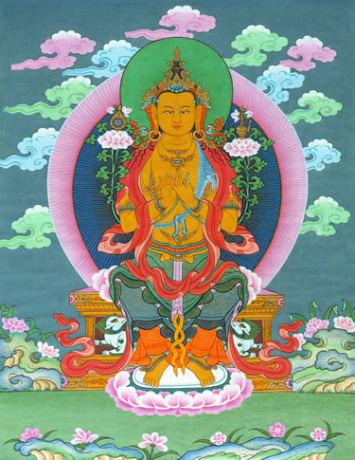

Maitreya
Buddha Maitreya is the embodiment of the loving-kindness of all Buddhas.
His hands are in the gesture of teaching Dharma, holding the stems of two lotuses symbolizing his omniscient wisdom of the three times.
The lotus on his right supports the Wheel of Dharma, symbolizing that he is the fifth founding Buddha of the thousand Buddhas of this Fortunate Aeon (Buddha Shakyamuni is the fourth)
The vase on his left is filled with life-giving nectars. He is seated in a posture indicating his readiness to arise in response to the needs of the world.
At the time of Buddha Shakyamuni, he manifested as a Bodhisattva disciple.

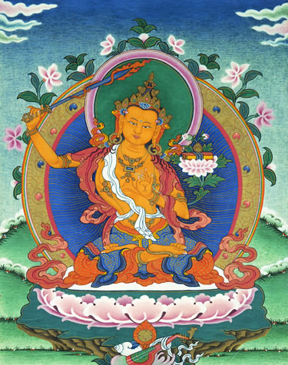
Manjushri
Buddha Manjushri is the Wisdom Buddha - the embodiment of the omniscient wisdom of all enlightened beings.
His left hand is in the gesture of teaching Dharma and holds the stem of a lotus flower that supports the Perfection of Wisdom Sutra.
The flaming sword in his right hand symbol-izes the power of wisdom to cut through ign-rance, the root of all suffering. By relying upon Buddha Manjushri, our own wisdom naturally increases.
For more information, see the book Heart Jewel, the sadhana Treasury of Wisdom, and the CD Songs of Wisdom & Compassion.

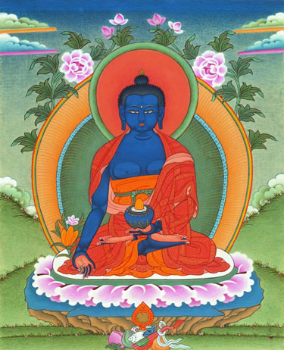

Medicine Buddha
Medicine Buddha’s function is to release living beings from physical and mental sickness by bestowing blessings on them.
His body of blue wisdom light indicates that he is an emanation of the healing power of all enlightened beings.
Through this practice, we develop a special power of body, speech, and mind, which we can then use to help others through healing actions.
The practice can be found in Medicine Buddha Sadhana, the audio version of which is on the CD Songs of Healing.

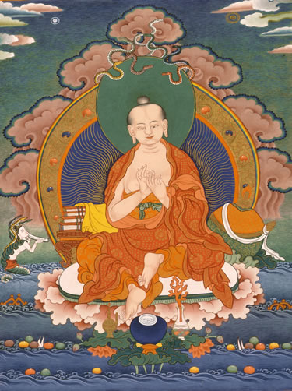

Nagarjuna
Nagarjuna was a great Indian Buddhist scholar and meditation master who devoted himself entirely to reviving the Mahayana Dharma in the first century AD and who brought to light the teachings on the Perfection of Wisdom Sutras.
Nagarjuna’s extraordinary life and works were prophesied by Buddha Shakyamuni. For his life story, see the book Ocean of Nectar.

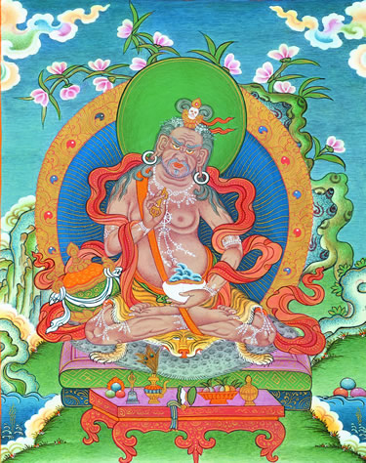

Naropa
Naropa (AD 1016-1100) is an Indian Buddhist Mahasiddha.
Our lineage of Vajrayogini practice is called the Narokhachö lineage because Buddha Vajrayogini transmitted these instructions directly to Naropa, who diligently put them into practice and as a result gained great realizations.
From Naropa, these instructions passed through an unbroken lineage of realized practitioners to the present-day.
For the instructions on Vajrayogini, see the book Guide to Dakini Land.

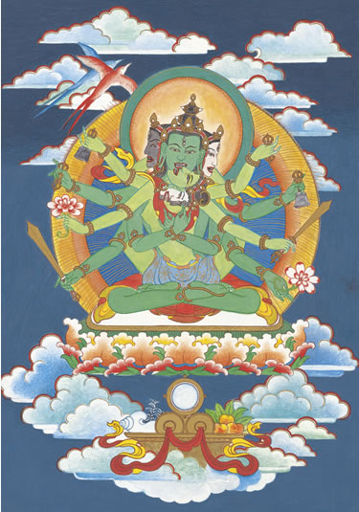

Samayavajra
The practice of Samayavajra is mainly for purifying degenerated commitments and vows.
Samayavajra is a Tantric Buddha who gas a green-colored body, three faces, one green, one black, and one white. He has six hands. The first two embrace his consort, who is similar in appearance. The other two right hands hold a vajra and a sword, and the other two left hands hold a bell and a lotus. Both the Father and the Mother are adorned with various jeweled ornaments.
The practice of Samayavajra can be found in the book Guide to Dakini Land.

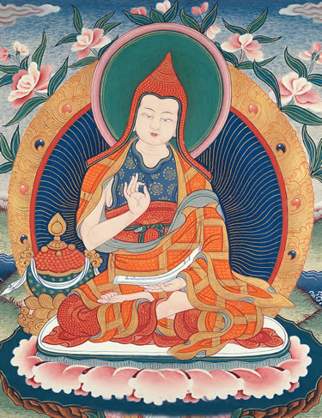

Shantideva
Shantideva (AD 687-763) was a famous Indian Buddhist master who composed the Buddhist classic Guide to the Bodhisattva's Way of Life.
A Bodhisattva is a friend of the world who, motivated by compassion, spontaneously seeks enlightenment. Many Kadampa practitioners keep Shantideva’s teachings in their hearts, and Je Tsongkhapa and his disciples greatly praised Shantideva’s work.
Both the Guide itself, and a full commentary called Meaningful to Behold, are available from Tharpa Publications.

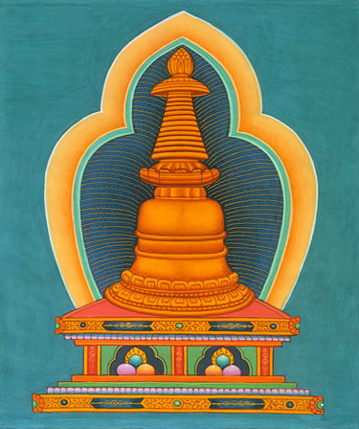

Stupa
The stupa represents Buddha’s mind.
Each aspect of a stupa symbolizes a facet of the enlightened mind or of the path leading to enlightenment, attainable by all living beings.
A traditional shrine or altar includes a picture or statue of Buddha (symbolizing Buddha’s body) in the center, a stupa or picture of a stupa on its right, and a text (symbolizing Buddha’s speech) on its left.

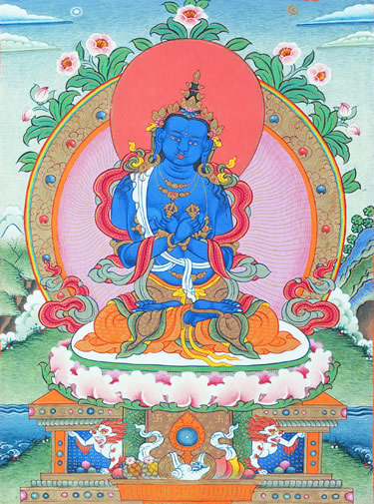

Vajradhara
Vajradhara is the founder of Vajrayana Buddhism, or Tantra. He is the same mental continuum as Buddha Shakyamuni but displays a different aspect.
He appeared as Buddha Shakyamuni to reveal the stages of the path of Sutra, and as Conqueror Vajradhara to reveal the stages of the path of Tantra.
Vajradhara said that in degenerate times he would appear in an ordinary form as a Spiritual Guide.
For more information, see the book Mahamudra Tantra.

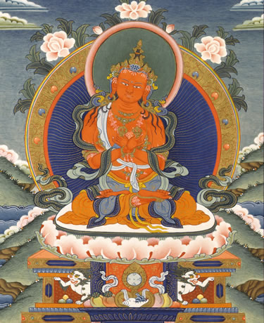

Vajradharma
In Vajrayogini practice, we visualize our Guru as Vajradharma, who is the manifestation of the speech of all the Buddhas.
He has a red coloured body, one face, and two hands, which are crossed at his heart and hold a vajra and bell. He is the same nature as Conqueror Vajradhara and looks exactly like him, except that he is red and adorned with six bone ornaments, whereas Buddha Vajradhara is blue and wears jewelled ornaments.
For more information on Vajrayogini practice, see the book Guide to Dakini Land.

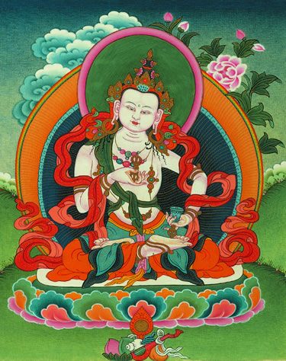

Solitary Vajrasattva
The practice of meditation and recitation of Buddha Vajrasattva is an extremely powerful method for purifying our impure mind and actions.
Vajrasattva is the aggregate of consciousness of all the Buddhas, appearing in the aspect of a white-coloured Deity specifically to purify living beings’ negativity.
He is the same nature as Buddha Vajradhara, differing only in aspect.
See the sadhana Meditation and Recitation of Solitary Vajrasattva and the CD Songs of Nirvana.

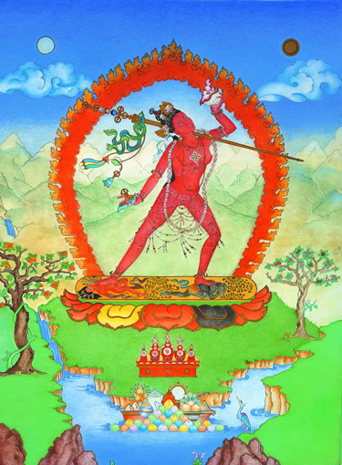

Vajrayogini
Vajrayogini is a female Highest Yoga Tantra Deity who is the embodiment of indivisible bliss and emptiness. She is the same nature as Heruka.
The instruction of Vajrayogini is the most profound teaching of Highest Yoga Tantra. In many respects, it is ideally suited to the present day, for example because it reveals how we can transform our attachment into the spiritual path.
Originally taught by Buddha Vajradhara within Heruka Tantra, it is the supreme method for purifying our environment, body, and mind, and is one of the main practices of our Kadampa tradition.
For a commentary to the practice of Vajrayogini, see the book Guide to Dakini Land.

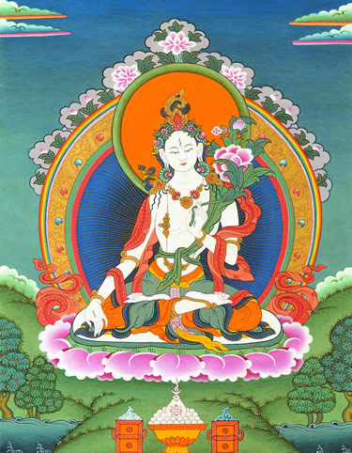

White Tara
White Tara is a female enlightened being whose function is to bestow long life, wisdom, and good fortune.
If we rely upon her with faith, she will protect us from contagious diseases, the dangers of fire, and other disasters.
It is said that living beings receive Tara’s blessings as swiftly as the wind moves because she is the manifestation of the wind element of all Buddhas.
See the sadhana The Yoga of White Tara, and the CD Songs of Long Life.

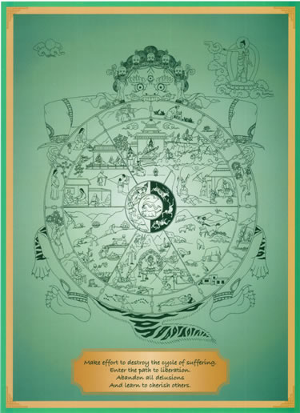

Rueda de la vida o del Dharma
Significa el ciclo de las reencarnaciones y también el camino de las cuatro verdades.
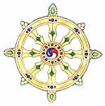

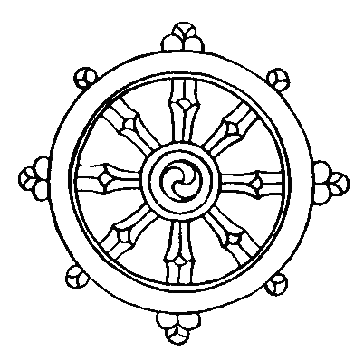
La rueda del dharma. Representa las cuatro grandes verdades y el ciclo de las reencarnaciones.

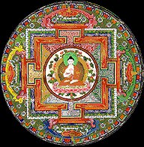

Mandala

En el tantrismo, se busca la vivencia intensa de las cualidades que se necesitan para llegar a la iluminación. En él se usaban mantras (entonces, una especie de hechizos mágicos), mandalas (diagramas ocultos) y mudras (gestos simbólicos). El símbolo (y realidad en algunas tendencias del tantrismo) de la iluminación tántrica es la unión sexual.

Imágenes sobre el Tíbet y el lamaísmo

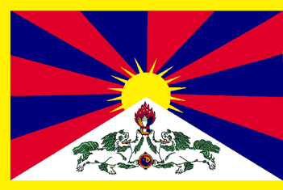
Bandera del Tíbet

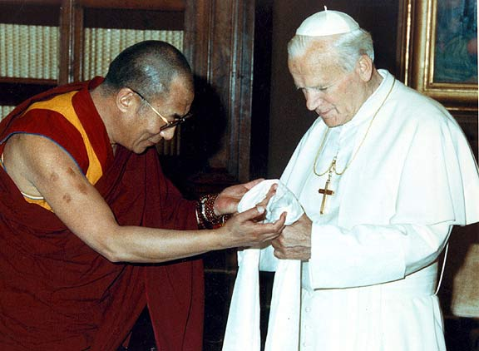
El Dalai lama con Juan Pablo II en 1982

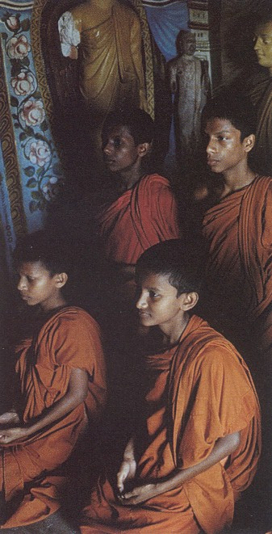
Monjes tibetanos

Viven en monasterios.
Los monjes budistas viven retirados en sus monasterios. No pueden tomar parte en danzas profanas, sesiones de teatro, fiestas en general. No pueden llevar adornos, no pueden usar ungüentos y perfumes.
Ataviados con su típica túnica azafrán (vestido con una túnica de este color se dice que murió Buda), con algún utensilio para la reparación del vestido, rasurada la cabeza y con un cordón de 108 bolas para rezar y una escudilla para mendigar el alimento... el monje caracteriza al budismo.
El monje ha de mendigar el alimento de cada día. Al pedir limosna hace un favor al laico pues le ofrece ocasión de realizar una buena obra. Por esa razón es el laico quien le da las gracias al monje a la par que le ofrece el alimento.
El ideal de vida de un budista no es llegar a ser hombre santo, sino un hombre «iluminado». Toda la austeridad se encamina sólo a apagar el deseo interior con el fin de poseer la ansiada libertad por el ejercicio de la meditación.
Es esta meditación por donde llegará a la experiencia profunda del yo y del no-yo. La perfección consiste en que el monje pierda conciencia de todo. Entonces sobreviene la liberación. Así llega a percibir cómo el mundo y su cambio constante, con todo el sufrimiento, no es más que una apariencia. De este modo llega a pregustar la alegría eterna del Nirvana. Cuando despierte de la meditación a la vida normal, volverá al mundo del sufrimiento, pero habrá experimentado un poco la felicidad del Nirvana. Con la repetición irá anulando dentro de si todo deseo. Si al morir está libre de los afanes de la vida, entrará definitivamente en el Nirvana.

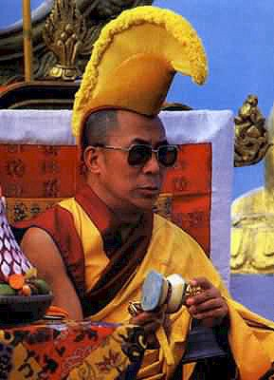

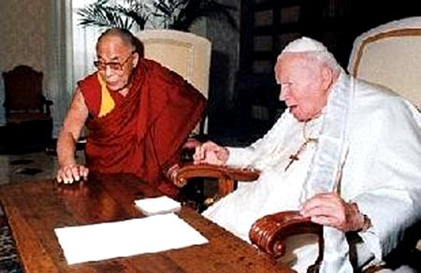
En el 2003.

Chistes:

